

**Fundamentals of Programming Lab 4**

**Name: Muhammad Amad Naeem**

**Section/Batch: ME-15 section-B**

**ID: 467469**

**Professor: Sir Affan**

**Task#1:**

#include<iostream>

using namespace std;

int main(){

int i,x,z=0;

cout<<" find the sum of first how many natural numbers?"<<endl;

cin>>x;

for(i=1;i<=x;i++){

z+=i;

}

cout<<z;

return 0;}

**Output:**

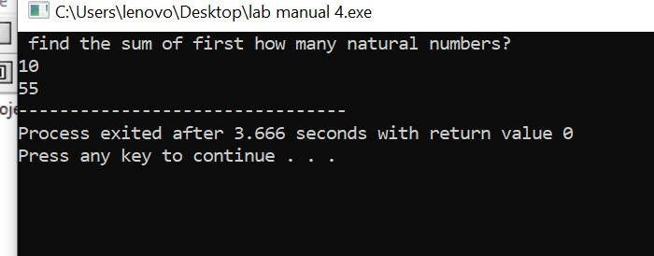

**Task#2:**

#include<iostream>

using namespace std;

int main(){

int i,x,b;

cout<<" print the table of: ";

cin>>x;

for(i=1;i<=10;i++)

{b=x*i;

cout<<x<<" x "<<i<<"= "<<b<<endl;

}

return 0;}

**Output:**

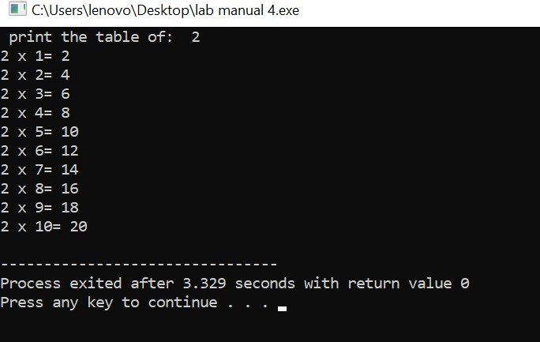

**Task#3**

#include<iostream>

using namespace std;

int main(){

int x,i,b=1;

cout<<" find the factorial of: ";

cin>>x;

for(i=1;i<=x;i++)

{ b=b*i;}

cout<<b;

return 0;}

**Output:**

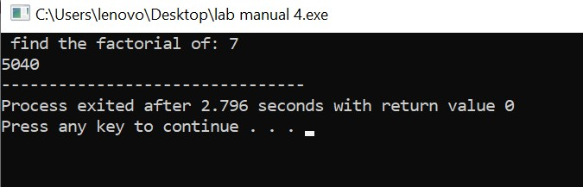

**Task#4:**

#include<iostream>

using namespace std;

int main(){

int a,b,c,i,d;

cout<<" enter the starting 2 values"<<endl;

cout<<"num1: ";

cin>>a;

cout<<"num2: ";

cin>>b;

cout<<"the sequence must end at which term?"<<endl;

cin>>c;

cout<<endl<<a<<endl<<b<<endl;

for(i=1;i<=c-1;i++)

{ d= a+b;

a=b;

b=d;

cout<<d<<endl;

}

return 0;}

**Output:**

